INDIVIDUALLY GUIDED SILENT RETREAT
Chalmersquoy, Isle of Westray (ORKNEY)
22 – 30 May 2024
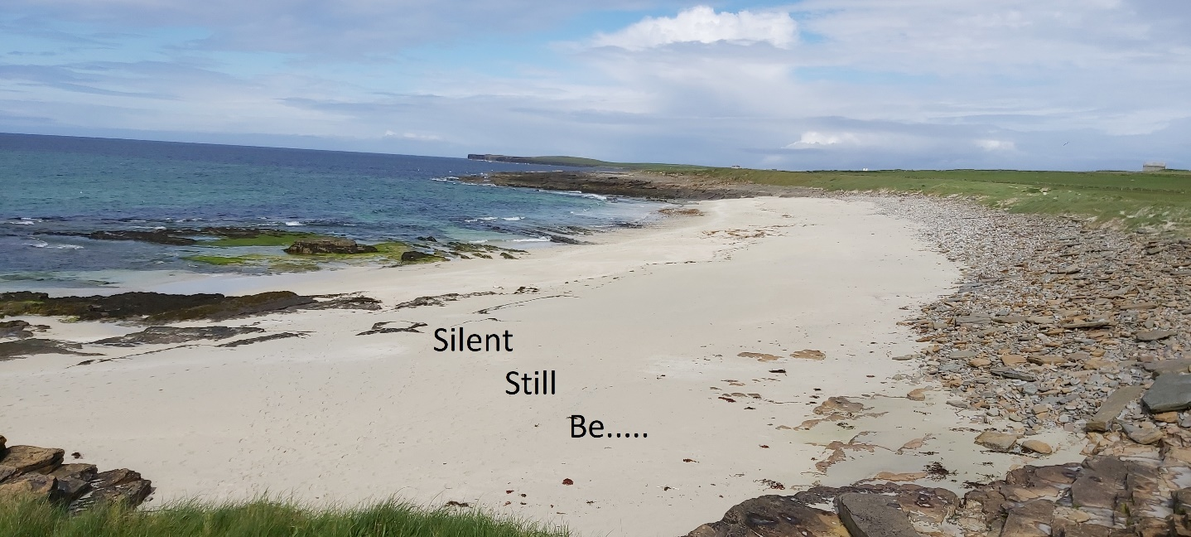

We are offering a 7-day retreat in the beautiful setting of Chalmersquoy on the Isle of Westray.
Sense of place is an important part of a retreat and Westray does not disappoint! Together with the deeply quiet atmosphere of the island, made tuneful with bird calls and the wash of the sea, the welcoming friendliness and non-intrusive interest of the islanders also awaits you.

“Westray has been a beautiful, sacred location for this retreat. The accommodation, the silence, the nature all at its best” (Retreatant, May 2023).

The retreat is designed to be a gentle and supportive introduction to the whole life-giving experience of a silent retreat.

What is a silent retreat?
A silent retreat allows you to take time away from your daily life to create space to reflect on your life and God’s presence with you, however you experience the mystery of God. As the name suggests, most of it will be conducted in silence!

On arrival, we will all gather for a simple soup lunch. On that first evening we will go through together the practicalities of the retreat, introduce you to your prayer guide and say a bit more about being with silence. You will meet the other retreatants and have an opportunity to ask questions.

The silence will begin after the first evening meal, which we will share together. Once the retreat has begun, you will meet your prayer guide daily for about 30-45 minutes, when she will listen and offer suggestions for prayer and reflection, drawing inspiration from the Spiritual Exercises of St Ignatius and be guided by how God is present with you.

The silence will end when we gather for our communal meal on the last evening.

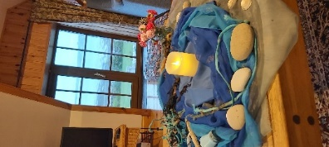
We will offer an optional half-hour reflection every evening in the sitting room of the hostel.

At other times, you can explore gentle or more challenging paths around the island, wander along expansive sandy beaches and enjoy the variety of bird life – including puffins! - on its rocky cliffs.

A certain amount of reading or listening to music might be helpful to bring, but you might like to discuss that with your prayer guide as sometimes it can be a distraction or an avoidance.

The retreat will be led by Pirjo Little, Seonaid Crabtree and Rachel Inglis, who are all members of the Epiphany Group. Pirjo lives on the Orkney Mainland where she is involved in The Christian Contemplative Network, Seonaid lives in the Western Isles and is a regular prayer guide at The Coach House, Inverness and Rachel lives in Galloway and works as a guest director at St Beuno’s Spirituality Centre, North Wales.

Accommodation

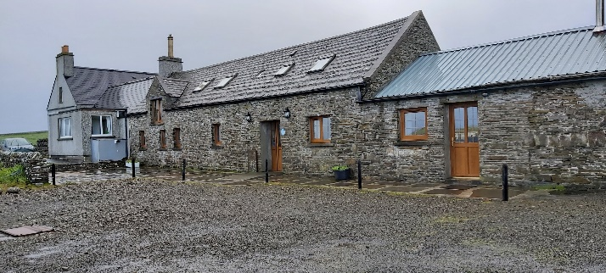

Chalmersquoy is an imaginatively converted former farm. The whole complex overlooks the peaceful Pierowall Bay and can be treated to fabulous sunsets. It offers four different types of comfortable accommodation designed to suit different budgets.

All costs below include accommodation, basic breakfast, two communal meals and a daily meeting with a trained retreat guide. All rooms are offered as single occupancy.

Venue No of rooms Type
Barn hostel 1 en-suite £635
Barn hostel 3 shared facilities/bunk beds £575
Barn hostel 1 sink in the room/double £595
Ben End 1 en-suite £675
Ben End 1 bathroom downstairs £615
B & B 3 en-suite £860
The Apartment 1 en-suite £890
We don’t want anyone to feel excluded because of finances. The Society of Retreat Conductors may be able to offer a grant (usually of up to 50%) so please look at their terms on their website: https://thesrc.org.uk/ .

Alternatively, write to Pirjo Little if you’d like further help.

Brief description of facilities
The Barn Hostel has a shared kitchen (L) and a lounge (C). Three rooms have bunk beds (R).

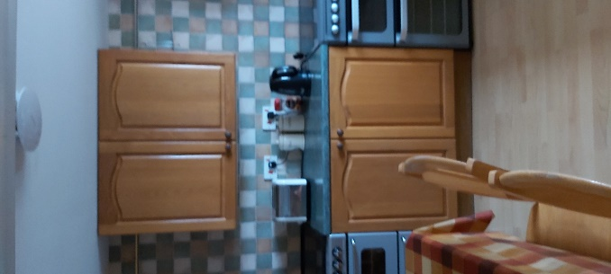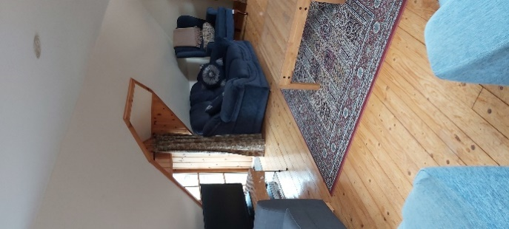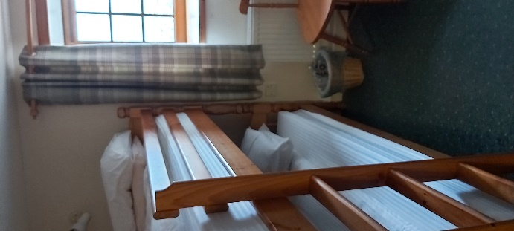

Ben End has a shared kitchen-cum-sitting area (L).

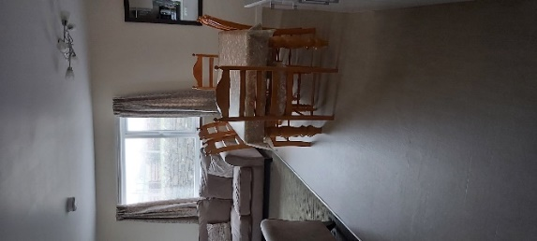
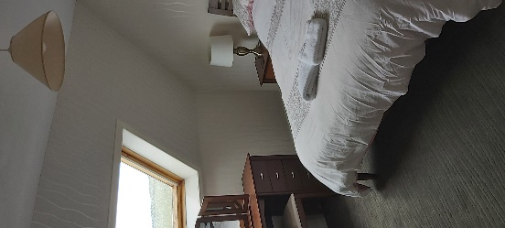

The B&B has three comfortable rooms (L), a shared kitchen and a sitting area.

The Apartment is self-contained, with a spacious kitchen-cum-sitting area (R), a breakfast bar overlooking the stunning Pierowall Bay, a large bedroom and a sun porch.

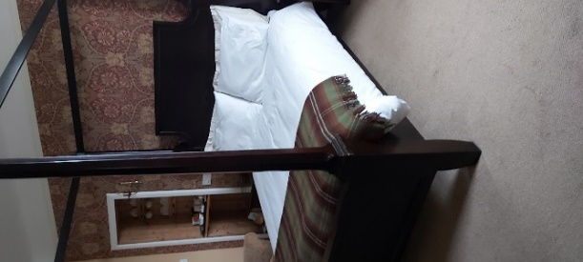
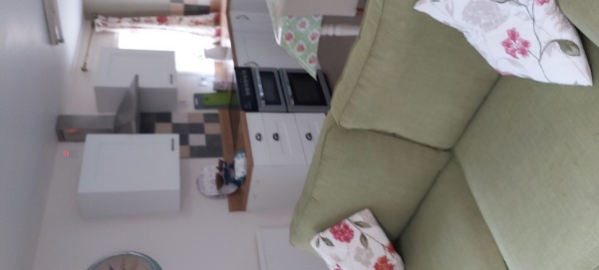

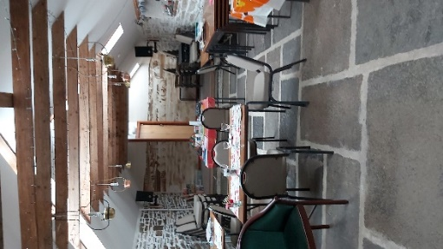
Graand Owld Byre (L) was originally a calving shed which has been converted into a cosy meeting room with a wood-burning stove. It retains some of the original features (but cleaned up!).
Photos by Pirjo Little

We will have our two communal meals here. During the retreat it will be set up as an art space equipped with a variety of art materials for you to play.

Catering
We will provide basic foodstuffs for breakfast which will suit most dietary requirements (see the booking form). To buy provisions for lunch and evening meal, there are two local shops, including a delicious bakery. If you prefer not to do any cooking, the Pierowall Hotel provides take-away home-cooked meals and the Fish & Chip shop is open twice a week.

“I liked that there were no set meal times, gave flexibility to get lost in things.”
“Loved the balance of communal meals and self- catering in between.” (Retreatants, May 2023).
Weather
The island weather is very changeable and tends to be breezy. Please be prepared for all seasons. Comfortable walking shoes are essential.
Travelling to Orkney
By ferry from Aberdeen (Tue, Thu, Sat and Sun) to Kirkwall
or from Thurso to Stromness daily - https://www.northlinkferries.co.uk
By ferry from Gills Bay to St Margaret’s Hope daily - https://www.pentlandbookings.co.uk

By air from Edinburgh, Aberdeen, or Inverness to Kirkwall - https://www.loganair.co.uk

Travelling to Westray
From Kirkwall to Westray by ferry - http://www.orkneyferries.co.uk/ The ferry goes three times a day most days
By air from Kirkwall to Westray - https://www.loganair.co.uk

It might be advisable to take out travel insurance against cancellations, etc.

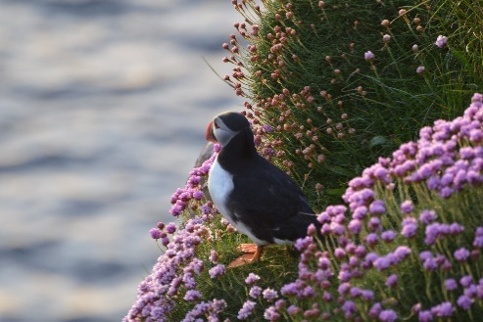

Photo by Claire Starr

BOOKING FORM:

Please either

Complete this form electronically and email it to: westray@epiphanygroup.org.uk

Or

Print off a copy and post the completed form to Pirjo Little, Finnhaven, Holm, Orkney KW17 2SA

Once we have confirmed your accommodation, we ask for a non-returnable deposit of £200. Payment can be made electronically (BACS) into: Account Name: Epiphany Group. Sort Code: 80-02-85. Account Number: 06002685. Please use as a payment reference your ‘initials/Westray’ to help us identify it.

If paying by cheque, please make it payable to ‘Epiphany Group’ and send it to Pirjo Little at the above address.

Please complete the form as fully as possible, and don’t hesitate to contact us on westray@epiphanygroup.org.uk if you have any questions.

PERSONAL DETAILS:
Name: _____________________________________________
Date of birth: _________________________ Religious affiliation: _________________________
Email: _____________________________________________
Address: _______________________________________________________________________________
______________________________________________ Postcode ________________________
Landline number: ____________________ Mobile number:________________________

Where did you hear about this retreat? ___________________________________
It would be helpful for us to know if you have any previous experience of an Individually Guided Silent Retreat – e.g. None / 6 / 8 / 30 day / other ______________________________
What are you hoping for from this retreat? __________________________________________
______________________________________________________________________________
BOOKING DETAILS:
I should like to book myself on the 7-day retreat, arriving 22nd May and departing 30th May 2024.
ACCOMMODATION:
Please mark with ‘X’ your preferred accommodation (if this isn’t available, we will be in touch to discuss an alternative)
Barn Hostel, en-suite …………………..
Barn Hostel, bunk beds, shared facilities …………………
Barn Hostel, sink in the room/double bed ……………….
Ben End, en-suite …………………..

Ben End, B/R downstairs …………

B&B accommodation……………..

Apartment, self-contained ………………….
Dietary requirements
The retreat will include basic breakfast and two communal meals, and otherwise will be self-catering. To help us provide the food you like and can eat, please indicate below with an ‘X’ if you have one or more of the following requirements:
Vegetarian ……………………….
Pescetarian……………………..
Vegan ……………………….
Gluten free ………………………..
Dairy free ……………………
No specific requirements …………………………
Please contact us at westray@epiphanygroup.org.uk if you have any specific food allergies not listed above and which we should be aware of.

Health

Please indicate if you have any current health conditions which you feel it would be helpful for us to know about. This information will only be shared with the team.

Emergency Contact

Please provide the details of the person we should contact in an emergency:

Name: _______________________________

Landline number: __________________________ Mobile number: ____________________

Email: ________________________________

Relationship to you (e.g. partner, relative, friend, neighbour) _______________________
Signed: ____________________________________
(You can type your name if replying electronically)
Date: _________________________________

The Epiphany Group is a group of women and men, both lay and ordained, working ecumenically across Scotland. We are rooted in Ignatian spirituality and committed in our Ignatian ministries to being agents for transformation.
For more about us, please see our website: www.epiphanygroup.org.uk

Westray 2024 flier: September 2023

