Some things we can do to make a difference ..…

A desire for action is ecological consolation. A desire to do something when a believer is touched by environmental issues is a form of consolation. We do well to respect that desire. It may indeed be a sign that we need to change our lives. Walter Ceyssens, The Way, October 2019

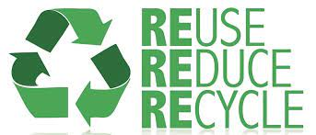

Around the home:
- Recycle
- Use the washing machine / dishwasher only when full - and less frequently.
- Turn off electrical plugs when not in use, and not to use 'standby'.
- Insulate our homes
- Ensure all our white goods are energy efficient
- Low energy bulbs
- Reduce / Reuse / Recycle
- Consider changing to carbon free heating systems in your home

Travel and transport:
- Reduce dependency on cars – walk more / cycle / car share /
- Fewer holidays by air
- Lobby local and national government for improved public transport provision

Food:
- East less meat & dairy
- Buy local and seasonal food
- Don’t buy food with airmiles attached

Garden:
- Plant bee-friendly flowers and grasses
- Grow vegetables amongst the flowers
- Support local cut flower suppliers
- Avoid using peat-based bags of soil and petition local garden centres to stop selling them.

Activism
- Join a local group that is working to this end
- Start a group if there is no group in existence
- Lobby your local and national councillors and MSPs

