We have come to a ‘moment of truth’. Covid and climate have brought us to a threshold. UN Secretary General Antonio Guterres

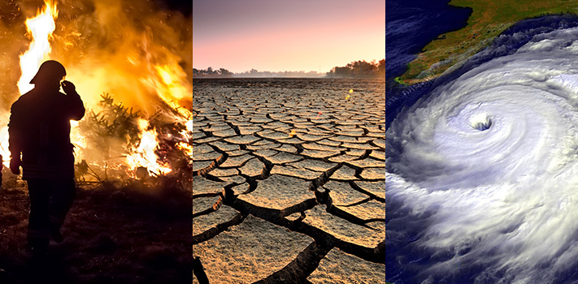
Climate change will be awful for everyone but catastrophic for the poor. Developing countries are feeling the impacts of climate change first and worst because of vulnerable geography and lesser ability to cope with damage from severe weather and rising sea levels. European Parliament

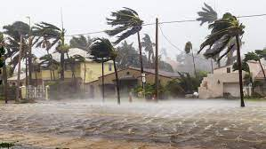

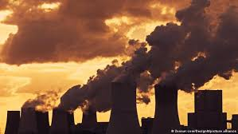

In the last 60 years CO₂ has increased 100 times faster than the natural increases which occurred at the end of the last ice age. Co-Director of Grantham Institute for Climate Change, Martin Siegert
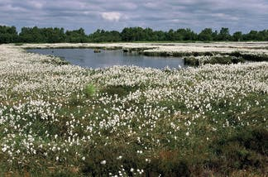

Ecosystems like peatlands play a crucial role in the carbon cycle. Roughly the same amount of carbon dioxide is stored in the peatlands in the UK as in the forests of the UK, Germany and France combined. Nature Scotland, Peatland action case study & BBC

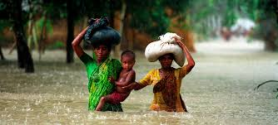

Today, climate change is felt primarily through a change in water, putting millions of children at risk.

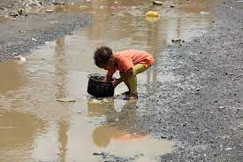

Between 2001-20018 around 74% of natural disasters were water related such as droughts and floods. The frequency and intensity are expected to increase with climate change.

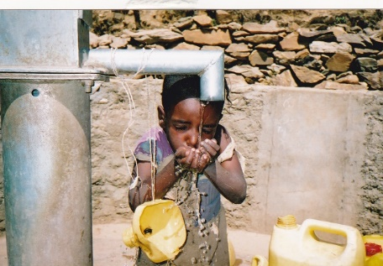

Around 450 million children live in areas of high, or extremely, high water scarcity. This means not enough water for daily needs, leading to competition and even conflict. Unicef

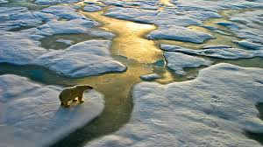

Climate change affects temperature and rainfall, which in turn causes loss of habitats and depletes ecosystems. The related loss of biodiversity reduces nature’s ability to store carbon, thus exacerbating climate change. These have grave consequences on the environment, on human wellbeing, on public health and on food security. World Economic Forum

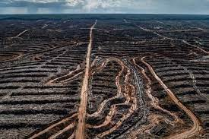

Global food demands increase the urgent need for more agricultural land. Virgin habitats are being stripped of forests, releasing CO₂ into the air. In the US agriculture-related emissions form 11.6% of the world’s greenhouse gas emissions. World Economic Forum

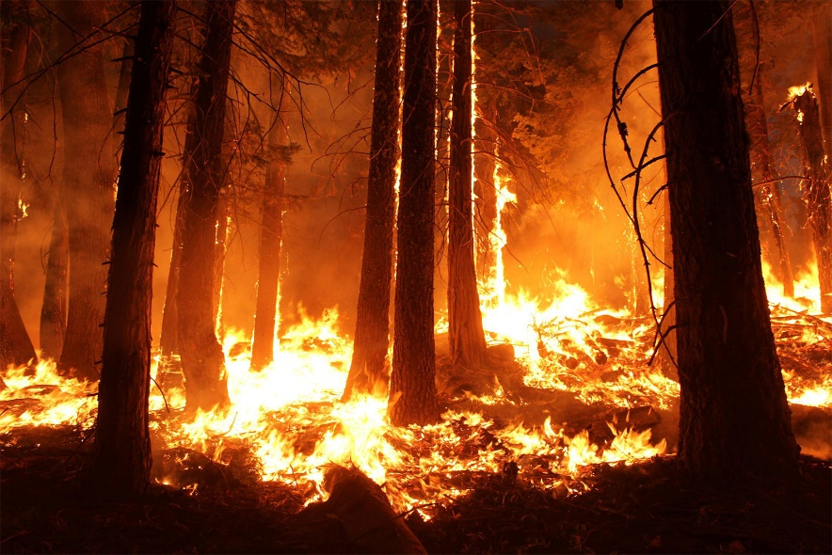

Changes in climate and weather put lives at risk. Wildfires bring multiple health risks and flooding leads to spread of waterborne diseases and injuries. National Oceanic and Atmospheric Administration

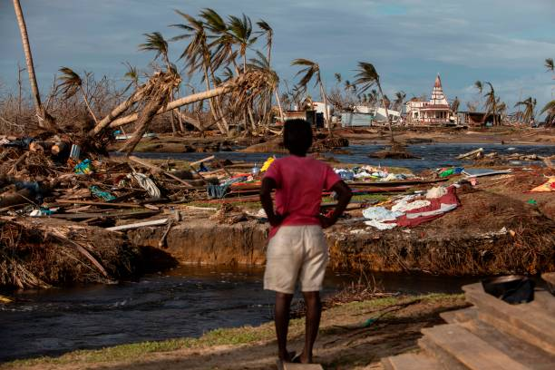

The richest 10% of people on the planet contribute half of the carbon emissions. The poorest 50% add only 10% of the emissions. It is the poorest communities and the young who pay the price of carbon inequality. Oxfam International website (accessed 16-11-21)

Today there are roughly 25 million climate refugees. This figure is expected to double over the next five years. (United Nations)

By 2030 an estimated 100 million people in developing countries could be pushed into poverty by climate change. World Economic Forum

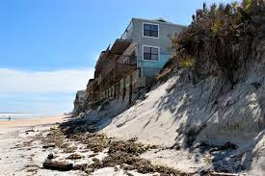

By 2050 rising sea levels could affect 570 coastal cities and1 billion people could be displaced. World Economic Forum

ACKNOWLEDGEMENTS:

Digital images mainly from the internet

Facts about climate change are taken from:
Oxfam International website
Nature Scotland website
UNICEF website
World Economic Forum website
COP26/BBC
Martin J Hodson and Margot R Hodson: A Christian Guide to Environmental Issues by SPCK

