Enneagram Workshop
June 29th, 2019
at Birse Kirk, Birse by Aboyne, AB34 5BY.
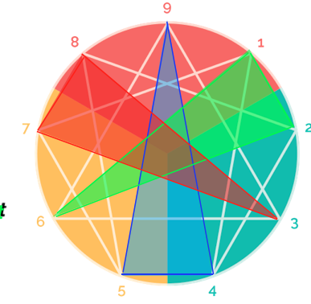

Description of Event
Often misunderstood as a personality typing method, the Enneagram is a sophisticated map designed to foster spiritual growth and personal transformation. Rather than putting people in boxes, as most personality typing tools do, the purpose of the Enneagram is to get people out of the box into which they have, unconsciously, put themselves. It is all about making the journey from Ego to Essence, from Shadow to True Self.
Participants will be given a brief history of the development of the Enneagram from its roots in the wisdom tradition of the Desert Fathers to the insights of modern psychology. You will then be introduced to the basic triadic framework of the Enneagram (meaning the diagram of nine), and the basic dynamic that gives rise to the personality. Finally you will be given a taste of the journey from Ego to Essence of all nine types and of spiritual practices that facilitate that journey.
It will not be possible for participants to know with certainty what type they are from attending this event. And it is rarely the case that anyone is just one type. The purpose is to grow, not only into the fully awake manifestation of your own dominant type, but also to grow towards the strengths of all the other 8 types.

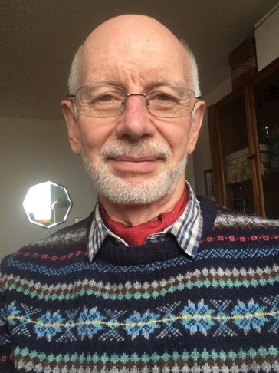
Facilitated by Rev Dr. Ken Webb
Born in China and brought up in Burma, Ken graduated from St Bartholomew’s Hospital, University of London to practice medicine first in the UK and then, for many years, in Thailand. He went on to study theology at Trinity College Bristol, graduating in 1992, and was ordained into Anglican ministry after a further year of post graduate study. He served a curacy in Cheltenham before returning to Thailand to start up a new bilingual international congregation at the invitation of the bishop of Singapore. Returning to Scotland in 2001 he was licensed as rector of Christ Church Duns in 2002. He spent the last five years before retiring in 2017 overseeing the training of those preparing for authorised ministry in the diocese of Edinburgh. Ken was introduced to the Enneagram in 1995 and began to delve more deeply into it in 2014, undertaking a number of courses put on by the Shift Network and Enneagram Institute.

PLEASE REGISTER THROUGH CAROLE PHELAN AT carole.phelan@talk21.com (07714091418)
Workshop from 10 a.m. till 4 p.m. with coffee at 9.30 p.m.
Please bring your own sandwich lunch.
£25 payable on the day.

